**CAPE Laboratory Assignment-5**

Instructor: Dr Debashis Sarkar

*18CH10071, Anshuman Agrawal*

**Problem Statement**

Consider a catalytic reactor of length L = 1 where a first-order reaction A → B takes place. The reactor model that describes the concentration of A in the reactor (CA) and concentration of A on catalyst surface (CAs) can be described as follows:



Model parameter values: u = 1, kg = 0.02, k = 0.01, a = 200, CA (0) = 1

Determine the axial profiles of concentration CA and CAs in the reactor.

1. Solve the DAE using ODE solver (like *ode45*) and algebraic solver (like *fsolve*).
2. Analytical solution is also possible here. Compare numerical and analytical solution.

**MATLAB Code**

clear all;

global u a kg k; % Model Given Parameters

u = 1;

a = 200;

kg = 0.02;

k = 0.01;

CAi = 1; % Initial Condition on CA

length = [0,1];

[z,sol] = ode45(@(z,y) reactor_func(z, y),length,CAi); % Solving ode

plot(z,sol,'-o','LineWidth',2); % Plotting CA vs z

hold on;

plot(z,(kg/(k+kg))*sol,'-.','LineWidth',2); % Plotting CAs vs z

legend('CA','CAs');

function func = reactor_func(z,y) % Defining function for ODE

global u a kg k;

CA = y;

CAs_initial_guess = CA;

CAs = fsolve(@(Cas) Alg_Eqn(CA,Cas),CAs_initial_guess); % Solving Algebraic part

func = -(kg*a/u)*(CA - CAs);

end

function y = Alg_Eqn(CA,CAs) % Defining function for Algebraic Equation

global u a kg k;

y = kg*(CA-CAs) - k*CAs;

end

**Analytical Solution**

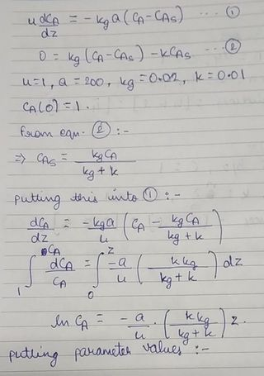

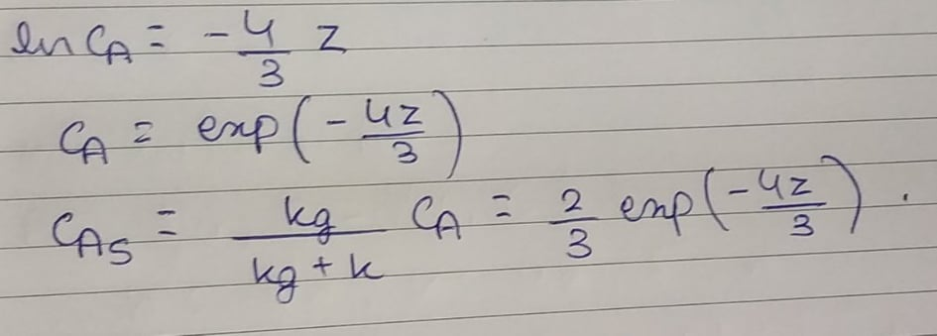

**Results**

**MATLAB**

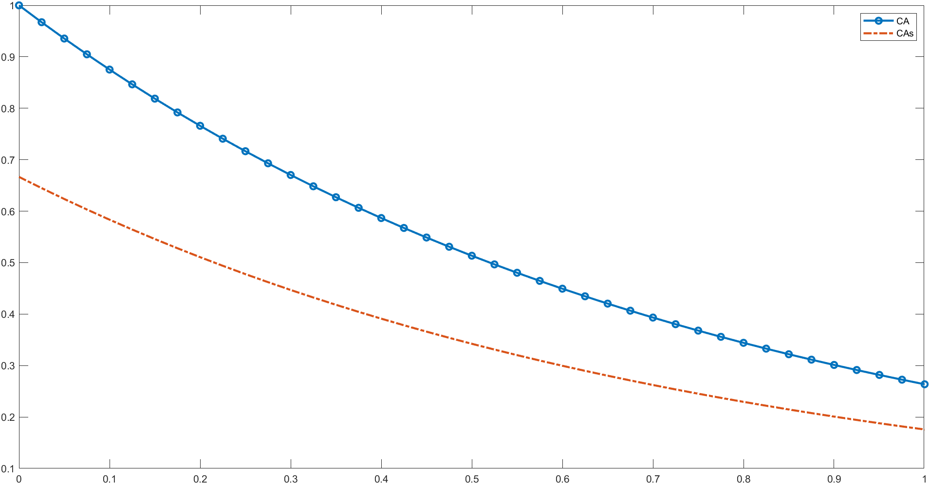

**Analytical solution**

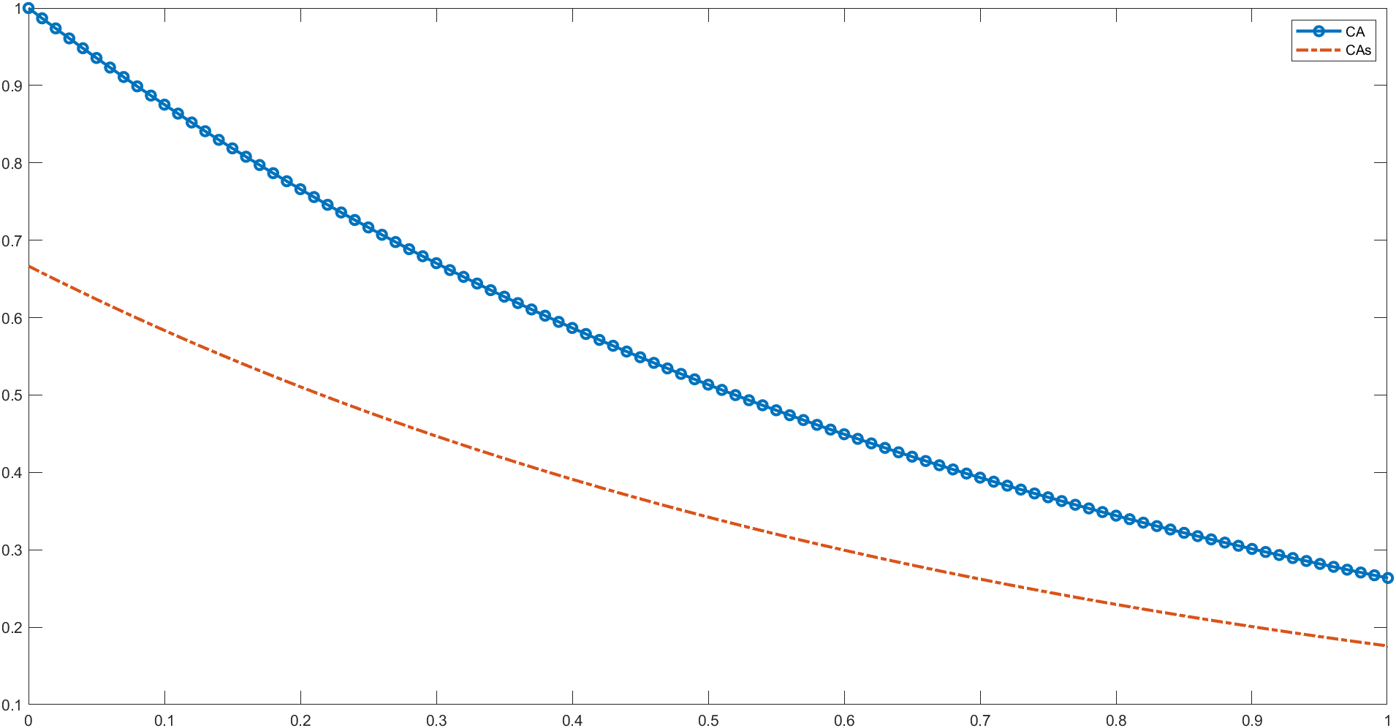

**Conclusion**

The analytical solution and the numerical solution obtained using *ode45* and *fsolve* come out to be very similar. The plots are mostly same for both CA and CAs using both methods. For increasing the precision further, the span could have been divided into a greater number of points but there are risks of overfitting. The given system was non stiff and linear too thus, a very simple system and thus, returned similar results. If we had stiff or non-linear or both together in a system, then systems could’ve returned different results by using these solvers. Non-linearity would have required convergence and thus, choosing an appropriate initial guess would’ve become important. There would’ve been additional error in the numerical methods owing to the truncation error involved in the methods. This kind of systems can also exist in process control systems, where we need to linearize the system systems by considering steady state which results in a DAE. For DAE systems with higher index, the computational complexity would have been higher.